

DENEY RAPORU

Deney Adı | EXTRACTION OF DC CHARACTERISTICS OF BJT AND MOSFET
Deneyi Yaptıran Ar. Gör. | Hacer ATAR YILDIZ
Raporu Hazırlayan  (İsim / Numara / Bölüm) | Emre GÖKREM / 040100124 / Bilgisayar Müh.
Grup Numarası ve  Deney Tarihi | D27 11.10.2013

Rapor Notu | Teslim Edildiği Tarih | Teslim Alındığı Tarih
 | 21.10.2013

Purpose

Aim of experiment is that relationship between current and voltage with DC in BJT and MOSFET is seen. We measure values and determine regions (saturation,reverse-active,forward-active,cutoff)

EXP-2.1 – Forward-Active Region in BJT

We chose V_{CE} = 5V and evaluated other values (R_{1,} V_{BE,} I_{C,} V_{R2}). Then we computed I_{B} ve β by formulas.
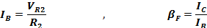

R₁ | V_{BE} | I_{C} | V_{R2} | I_{B} | β
1 MΩ | 0.62 V | 0.97 mA | 40.32 mV | 4.032 μA | 240.57
680 KΩ | 0.639 V | 1.42 mA | 57.96 mV | 5.796 μA | 244.99
470 KΩ | 0.652 V | 2.31 mA | 93.7 mV | 9.370 μA | 246.53
330 KΩ | 0.660 V | 3.10 mA | 125.27 mV | 12.527 μA | 247.46
220 KΩ | 0.671 V | 4.50 mA | 181.51 mV | 18.151 μA | 247.93
150 KΩ | 0.678 V | 6.06 mA | 0.24 V | 24 μA | 252.5
100 KΩ | 0.691 V | 9.85 mA | 0.38 V | 38 μA | 259.21
68 KΩ | 0.701 V | 14.09 mA | 0.55 V | 55 μA | 256.18
47 KΩ | 0.711 V | 19.85 mA | 0.77 V | 77 μA | 257.79
33 KΩ | 0.715 V | 24.58 mA | 0.94 V | 94 μA | 261.48
22 KΩ | 0.724 V | 34.64 mA | 1.32 V | 132 μA | 262.42

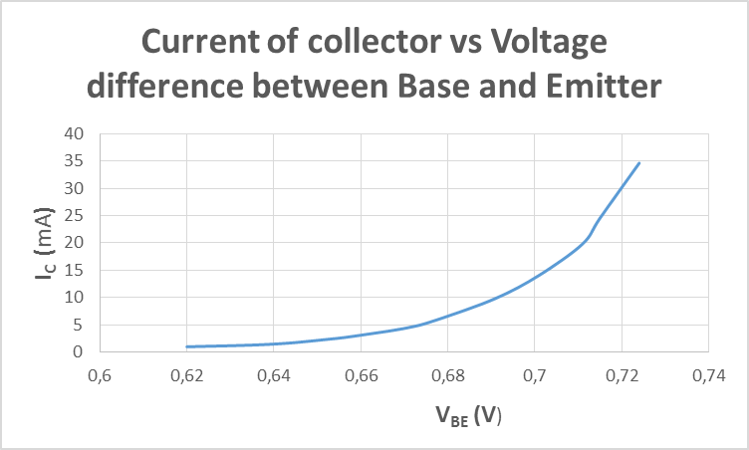
We seen changing between I_{C} and V_{BE}. I_{C} increased exponantially depending on V_{BE}.

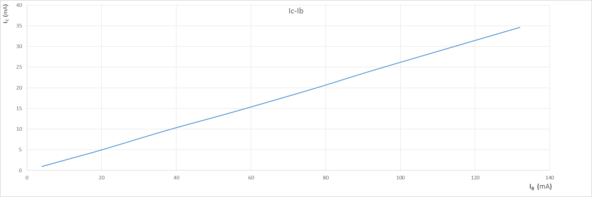

While I_{C} was increasing, I_{B} was increasing linearly. These changings is fit for formulas.

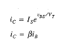
EXP-2.2 – Reverse-Active and Saturation Region in BJT

In this experiment, we changed circuit to reverse and saturation mode. We changed locations between emitter and collector.
 | V_{BE} | V_{CE} | I_{B} | I_{C} | β
Forward-active Mode | 0.724 V | 5 V | 132 μA | 34.64 mA | 262.42
Reverse-active Mode | -4.37 V | -5 V | 197 μA | 1.036 mA | 5.25
Saturation | 0.705 V | 34.54 mV | 435 μA | 4.34 mA | 9.97

Emittor and collector location was changed so these current and voltage values was changed.

EXP-2.3 – V_{GS} – I_{D} Characteristic in NMOS

In this experiment, we changed R and seen changing between V_{GS} and I_{D}.

V_{DS} = 5 V
V_{GS} | I_{D}
9.17 V | 13.28 mA
8.79 V | 12.33 mA
8.27 V | 11.08 mA
7.87 V | 10.13 mA
7.00 V | 8.08 mA
6.25 V | 6.43 mA
5.32 V | 4.56 mA
4.03 V | 2.32 mA
3.26 V | 1.26 mA
2.51 V | 0.51 mA
2.06 V | 0.21 mA

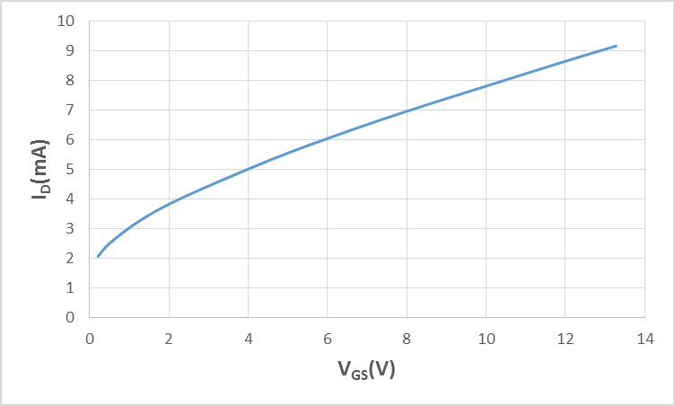

We looked characteristic changings. I_{d} was changed depending on V_{GS.} Changing is fit for regions formulas.
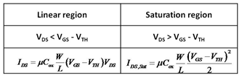

EXP-2.4 – V_{DS} – I_{D} Characteristic in NMOS

In this experiment, we changed V_{DS} and we looked changing between V_{DS} - I_{D}.

V_{GS} = 4.62 V
V_{DS} | I_{D}
0 V | -1.3 μA (0 μA)
1 V | 2.03 μA
2 V | 3.14 μA
3 V | 3.23 μA
4 V | 3.26 μA
5 V | 3.27 μA
6 V | 3.29 μA
7 V | 3.30 μA
8 V | 3.31 μA
9 V | 3.319 μA
10 V | 3.327 μA

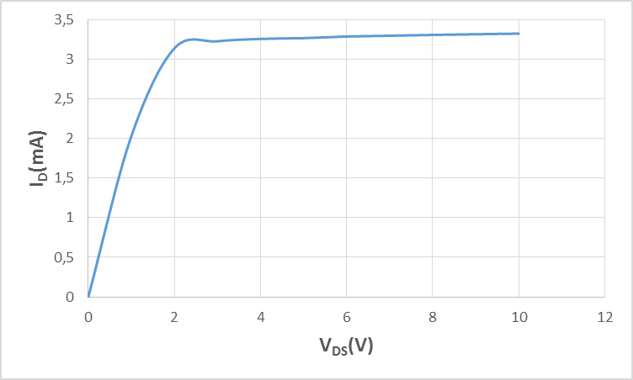

We looked that I_{D} is fixedly from 3,2 value.V_{GS} - V_{tn} > V_{DS}. V_{GS} and V_{tn} are constant so value of V_{DS} is critic for region between 2V-3V. We seen active region and saturation. Characteristic is fit for formulas.
